|  |  |
| --- | --- |
| **MAD2**  Diploma in IT  Year 2 (2018) Semester 4 | Week **1** |
| **3 hours** |
| **Practical 1: Introduction to Swift** | |

**Objectives**

At the end of this practical exercise, the students should be able to:

* Understand the syntax of Swift
* Write Swift program on “Playground”

|  |
| --- |
| **IMPORTANT**   * Create a folder, **week1**, in the local hard drive and save all your work in this folder. * At the end of the session, copy this folder (all your work) to MAD2 network folder so that your tutor may assess your work. * The path of MAD2 network folder is **\\ictspace.ict.np.edu.sg\MAD2** |

Example 1

1. Launch Xcode

2. Choose “Get started with a playground” and make sure the platform is set to **iOS**.

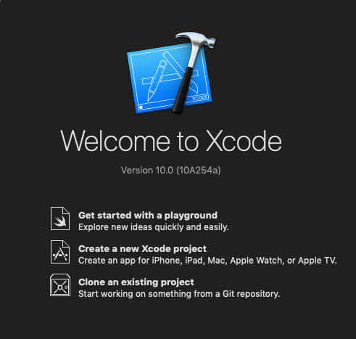

3. Leave the Name as “MyPlayground”

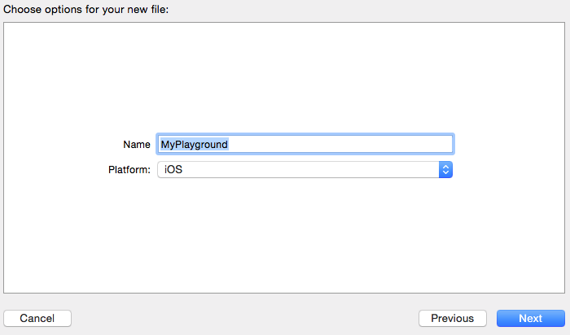

4. Save the file in one of the folder (create a new folder MAD2\Week 1):

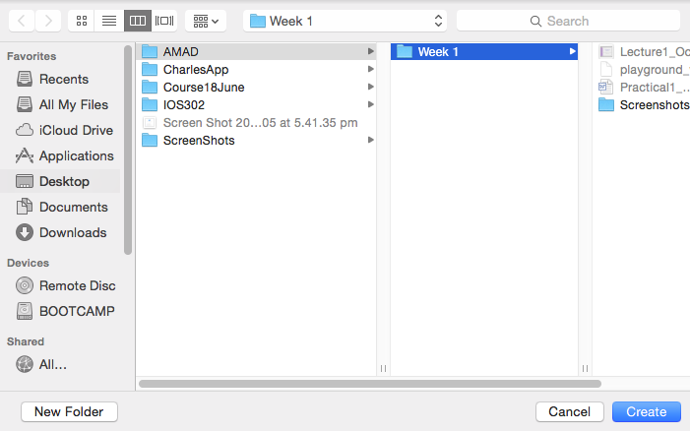

4. Playgrounds make writing Swift code incredibly simple and fun. Type a line of code and the result appears immediately. You can then Quick Look the result from the side of your code, or pin that result directly below.

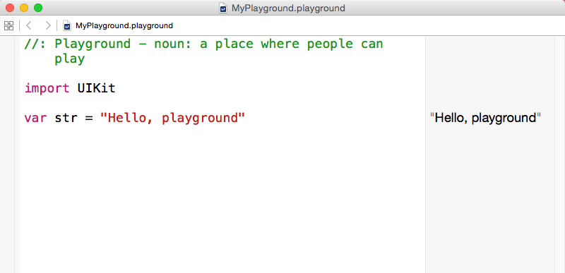

5. Delete the text in the playground and do the following exercises:

Exercise 1 Display the list of numbers from 1 to 20

Exercise 2 Display all the odd numbers between 1 and 20

Exercise 3 Display the sum of all the odd numbers between 1 and 20

Example 2

1. In MyPlayground file, add the following function:

// Declare instance function

func sayIt(aNumber: Int) {

print("You pass a " + String(aNumber))

}

2. Try out the function:

sayIt(5)

3. Observe the output.

Exercise 4 Write a function to return the String “Pass” or “Fail”, given an integer mark. The function signature is

func result(mark: Int)-> String { }

Exercise 5 Write a method to generate an array of 10 random numbers, and display the highest number in the array. The function signature is

func findMax(n: [Int])->Int { }

To generate a random number, x, between 0 and 100, use:

import Foundation

var x = arc4random_uniform(100) //UInt64

Exercise 6 Continuing from Exercise 5, write another function to find and display the lowest number in the array.

Exercise 7 Continuing from Exercise 6, write another function to find and display the average of the numbers in the array.